**Project Design Phase-II**

**Data Flow Diagram & User Stories**

|  |  |
| --- | --- |
| Date | 23-06-2025 |
| Team ID | LTVIP2025TMID49871 |
| Project Name | House Hunt |
| Maximum Marks | 4 Marks |

**Data Flow Diagrams:**

he DFD for **House Hunt** represents the flow of information between key actors (tenant, landlord, admin) and system components. It outlines how data like property listings, user profiles, bookings, payments, and messages are processed and stored

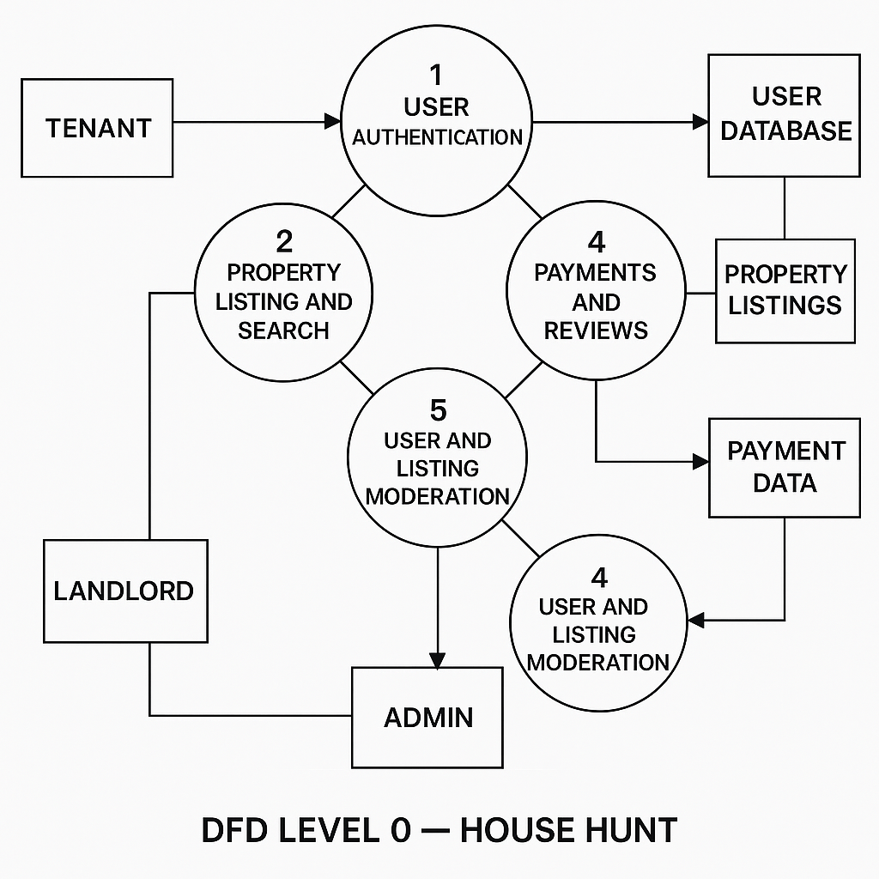

**User Stories**

**User Story Table – DocSpot**

|  |  |  |  |  |  |
| --- | --- | --- | --- | --- | --- |
| **User Type** | **Functional Requirement (Epic)** | **User Story / Task** | **Acceptance Criteria** | **Priority** | **Release** |
| |  | | --- | | **Tenant** |  |  | | --- | |  | | |  | | --- | | Property Discovery & Booking | | As a tenant, I can search for rental properties by location, budget, and features. | Listings returned based on filters and relevance.. | High | Sprint-1 |
|  | Booking Visits | As a tenant, I can book, reschedule, or cancel property visits. | |  | | --- | | Visit status updates in   dashboard  . | | Medium | Sprint-2 |
| |  | | --- | | **Landlord** |  |  | | --- | |  | | |  | | --- | | Listing  Management | | |  |  | | --- | --- | | |  | | --- | | As a landlord, I can create and update  property listings with images and   availability. | | | |  | | --- | | Changes reflect immediately in patient booking system. |  |  | | --- | |  | | High | Sprint-1 |
| **User** | Messaging | As a user, I can chat with the other party in real-time | Messages appear instantly. | Medium | Sprint-2 |
| **Admin** | Profile Management | As a Admin, I can update my profile. | Changes are saved successfully. | High | Sprint-2 |
| **Client** | Payment Processing | As a client, I can make secure payments after job completion. | Payment recorded and shown in transaction history. | High | Sprint-2 |
| **user** | |  | | --- | |  |  |  | | --- | | Review System | | As a user, I can leave a review after project closure. | Review appears on profile. | Medium | Sprint-2 |
| **Admin** | User Moderation | As an admin, I can review reported users and take action. | Reports and actions logged. | High | Sprint-1 |